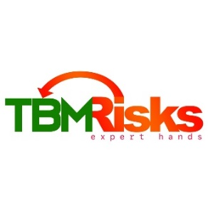

**TBM RISKS CONSULT**

**10 EXAMINATION DRIVE, NORTH RIDGE, ACCRA, mobile: +233(0)559557228/0248590955, email: tbmrisks@gmail.com**

**ABOUT US**

We are a risk management and collateral management company.

Our solutions have helped our clients save millions of cedis through the prevention of financial losses.

**HOW WE DO IT**

We expertly analyse the risks in our clients’ value chain and provide the most effective risk control solutions for them.

We deploy digital solutions together with manual operations to optimise our results.

We monitor contract executions to the satisfaction of stakeholders.

We monitor;

* Cocoa purchases and delivery
* Oil – tax guarantees and stakeholder agreements
* Supplies
* Port clearance
* Infrastructural developments
* Building construction projects

The Optis Platform

This platform is our digital antidote to risks associated with financing projects and supplies contracts.

The ***OPTIS-Ag*** version is purposefully built to manage risks associated with agricultural value chain financing.

CocoaAsempa Software.

The CocoaAsempa Software is a digital platform for purchasing cocoa, making online payments, doing real-time monitoring of cocoa deliveries and producing real-time reports.

**OUR CLIENTS**

We are currently working with financial institutions and developmental agencies to manage risks associated with project financing and issuing of bonds and guarantees.

*Financial Institutions*

Our clients in the following sectors; insurance, banking, commodity traders, project management and development financial institutions (DFIs).

Any organization that finances projects, supplies, oil marketing companies and cocoa purchases needs our solutions.

Our solutions offer disbursement control for commodity purchases, payments, real-time monitoring and reporting.

Financial institutions that used our solutions have reduced their risk of losses by as much as 95%.

*Licensed Buying Companies (LBCs):*

LBCs are licensed organisations in Ghana that purchase cocoa beans for the Ghana government for export. The buying activity is usually financed by the government through its regulator, COCOBOD, bank financing and self-financing.

The industry has long suffered financial losses due to theft, robbery and fraud among others. Sometimes robberies have led to loss of lives.

The payment side of the platform has eliminated that risk as money is now directly paid to the farmer or the purchasing clerk, the first line officer who interacts with the farmer to buy beans.

The benefit to LBC is operational efficiency and the prevention of financial losses.

**Our Team**

Our team comprises experts in Risk Management, Engineering, Law, Accounting, Insurance, Pensions, Audit, Finance and IT.

**SERVICES**

Digital Risk Management solutions

Risk Management Support & Advisory

Collateral Management